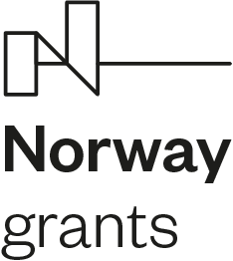 

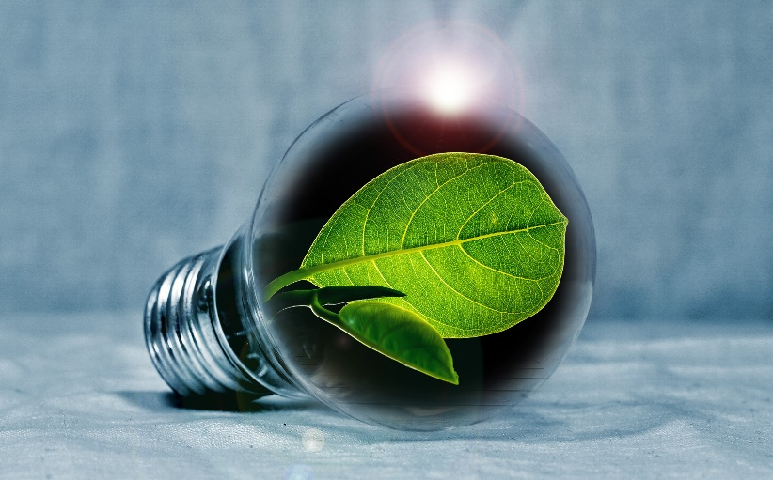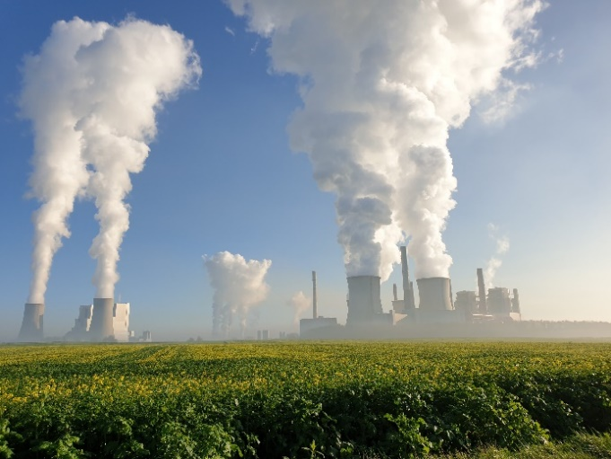

**Negative CO2 emission gas power plant**

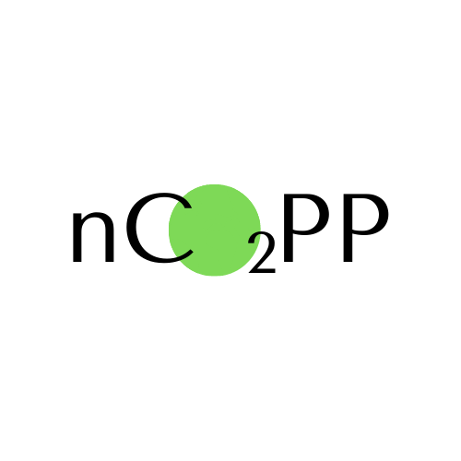

The primary objective of the project is to develop an innovative technology confirming the possibility of utilization of sewage sludge with subsequent carbon dioxide collection to produce electricity and in such a way showing a positive impact on the environment. The synergy between the CCS/CCU plant and the proposed utilization of sewage sludge (such fuel is considered as a renewable energy source) enables the installation to achieve overall negative emissions of CO2. The additional advantage of vitrification of sewage sludge, owing to sufficiently high process temperatures, allows turning this problematical waste into a marketable product.

Completion of the project will return the developed technologies for the management of syngas produced from sewage sludge gasification, and a dedicated wet combustion chamber with the use of oxy-combustion for the type of fuel developed. Finally, the CO2 sequestration will be demonstrated using the spray-ejector condenser (SEC) combined with a separator. These three aspects are major novelties of the project. Subsequently, the intention of partners is to develop container-based installation to demonstrate the capabilities of the developed technology. Once the system is integrated, it will be possible to capture CO2 from commonly recognized problematic waste and achieve a positive environmental impact, whilst generating electricity and heat.

**1st November 2020 – 30th October 2023**

**Lead partner:**

**Gdańsk University of Technology (Gdańsk Tech) – Poland**

**Project partners:**

**Institute of Fluid-Flow Machinery of Polish Academy of Sciences (IMP PAN) - Poland**

**Wrocław University of Science and Technology (WUST) - Poland**

**Norwegian University of Science and Technology (NTNU) - Norway**

**AGH University of Science and Technology - Poland**

**SINTEF Energi AS - Norway**

**Institute of Power Systems Automation Sp. z o.o. (IASE) - Poland**

**Bros Control Sp. z o.o. - Poland**

**“Applied Research” under the Norwegian Financial Mechanisms 2014 - 2021**

**POLNOR CCS 2019 – Development of CO2 capture solutions integrated in power and industry processes**

