****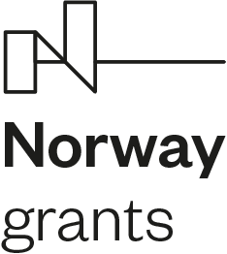

Gdańsk, 30th  April 2021

POLNOR CCS nCO2PP

**Name SURNAME1, Name SURNAME2,** **Name SURNAME3,   
Name SURNAME4, Name SURNAME2, Name SURNAME4, Name SURNAME1,**

1Affilation

2Affiliation

3Affiliation

4Affiliation

**Title**

**WP X Task X 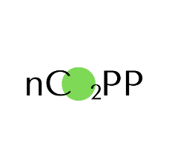 Report No. X**

**Principal Investigator: prof. Dariusz Mikielewicz – GDAŃSK TECH**

**Gdańsk, 2021**

# 

Project Contract: NOR/POLNORCCS/NEGATIVE-CO2-PP/0009/2019-00 ***nCO2PP - Negative CO2 emission gas power plant***- project co-financed by Programme "Applied research" under the Norwegian Financial Mechanisms 2014 – 2021.

Content

1 1

1 Introduction 3

1.1 Aims and scope 3

2 Chapter 3

2.1 Subchapter 3

3 Conclusions 3

4 Acknowledgments 3

5 Bibliography 4

# Introduction

This report was carried out for the project "Negative CO2 emission gas power plant" - implemented under the agreement No. NOR / POLNORCCS / NEGATIVE-CO2-PP / 0009 / 2019-00 signed on November 17, 2020 by NCBiR. The project was selected as part of the POLNOR CCS 2019 call for proposals and it is partially co-financed from the Norwegian financing mechanism for 2014-2021. The results described in the report constitute the last stage of works provided for in WP1 Task 1 and Task 2 for the period 01/11/2020-30/04/2021. The results collected in this report summarise the work resulting in the third milestone called: “Feasibility study of basing on thermodynamic analysis of negative CO2 emission power plant, based on oxy-combustion the gas from sewage sludge gasification in a gas turbine with spray-ejector condenser, coupled with CCS, backed up with calculations of the energy efficiency. Scientific article which presented the most important results”.

## Aims and scope

# Chapter

## Subchapter

# Conclusions

# Acknowledgments

The research leading to these results (Feasibility study of basing on thermodynamic analysis of negative CO2 emission power plant, based on oxy-combustion the gas from sewage sludge gasification in a gas turbine with spray-ejector condenser, coupled with CCS, backed up with calculations of the energy efficiency.) has received funding from the Norway Grants 2014-2021 via the National Centre for Research and Development.

Report: ”Feasibility study of basing on thermodynamic analysis of negative CO2 emission power plant, based on oxy-combustion the gas from sewage sludge gasification in a gas turbine with spray-ejector condenser, coupled with CCS, backed up with calculations of the energy efficiency.” has been prepared within the frame of the project: "Negative CO2 emission gas power plant” - NOR/POLNORCCS/NEGATIVE-CO2-PP/0009/2019-00 which is co-financed by programme “Applied research” under the Norwegian Financial Mechanisms 2014-2021 POLNOR CCS 2019 - Development of CO2 capture solutions integrated in power and industry processes.

# Bibliography